Migration and Development Seminar Series:

Facilitating migrants’ participation in society
Draft Programme

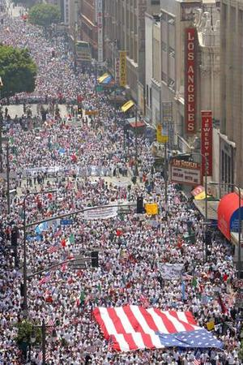

New York, 3 May 2007

The Migration and Development Series is financially supported by the John D. and Catherine T. MacArthur Foundation and UNFPA

Thursday, 3 May 2007
9:15 am Registration
9:30 am Opening remarks
Ms. Ann Pawliczko, UNFPA

9:45 am Introduction
Facilitating migrants’ participation
Rabbi Arthur Schneier, Member of the High Level Group of the Alliance of Civilizations, President, Appeal of Conscience Foundation and Senior Rabbi, Park East Synagogue, New York (tbc)

Models and measures of integration
Mr. Jack Jedwab, Executive Director, Association of Canadian Studies

10:30 pm Session I : Facilitating migrants’ participation: Gateways and facilitators
The role of local governments
Ms. Azi Khalili, New York City Mayor’s Office of Immigrant Affairs
Labour market participation: employment and business creation
Ms. Ansar Cheung, Program Director, Settlement and Public Education, United Chinese Community Enrichment Services Society (SUCCESS), Vancouver
Educational opportunities
Mrs. Unaiza Malik, Treasurer, The Muslim Council of Britain

1:00 pm Lunch

3:00 pm Session II : Facilitating migrants’ participation: International cooperation
Dialogue among civilizations
Mr. Shamil Idriss, Acting Director, Alliance of Civilizations Secretariat
A role for countries of origin?
Migrants’ contribution to development, transnational participation, dual citizenship
Mr. Fatmi Ben Souda, Adviser, Cabinet of the Minister-Delegate in Charge of Moroccans Living Abroad. Morocco (tbc)
Regional cooperation on migrant integration
IOM (tbc)
Recognition of qualifications
Ms. Xuesong Shen, Liaison Officer for Education, UNESCO New York Office

5:30 pm Update on the preparations for the Global Forum on Migration and Development
Ms. Christine Detaille, First Counsellor, Permanent Mission of Belgium to the UN

5:45 pm Summary of discussions

6:00 pm Closing remarks

